Assessment report to Ramsar STRP12
“Natural mitigation of natural disasters”

Introduction
The Ramsar Convention has asked Wetlands International to coordinate efforts to bring together scientifically sound advice on wetlands in the region in order to assist governments in choosing the most effective response measures. The IOPs, Wetlands International, WWF International, IUCN and BirdLife International, alongside IWMI, agreed to collaborate within a “Ramsar Tsunami Reference Group”. The Group has agreed to share assessments on the impacts of the tsunami on coastal wetlands in the affected areas of the Indian Ocean (including Eastern Africa) and to communicate with each other and other partners. The present report is very much a work in progress and states:
- What we do know
- What we don’t yet know, and;
- What we are finding out or will soon know

What we do know
This section aims to provide information towards the debate on “natural mitigation of natural disasters”: How did mangroves and other coastal ecosystems act during the tsunamis? The section also reports on the post-tsunami coastal wetland status, as far as it is presently known to the Group.

Current accepted opinion is that coastal wetlands can act as a green barrier to protect the coastline and its communities from storms, including waves, reducing erosion from wind and wave energy and mitigating damage. However, the evidence so far seen from satellite images is that in high energy situations such as Aceh province, Sumatra, complete loss of beaches, mangroves and severe localised damage to coral has occurred, indicating that in extreme events very little mitigation may be possible in those areas most exposed to the wave energy.

Away from the epicentre of the earthquake and tsunami, there are indeed localised usually anecdotal reports of reduction of damage behind mangrove stands, and coral reefs, but little quantitative data is yet available. None of the members of the Ramsar Tsunami Reference Group appear to have obtained firm evidence, however, there is a reasonable knowledge of focal areas worth investigating in detail, and gaps identified.

Specific evidence for coral reefs:

The Mauritian Wildlife Foundation (BirdLife) reported that the wave had no or very little impact on the island thanks to the coral reef barrier

Specific evidence for mangrove ecosystems:

Indonesia: Efrizal Adil (partner of WI-IP) In Bakongan, Aceh Selatan, approximately 160km from the epicentre of the earthquake, there are mangroves (Rhizopora), sea pine (cemara), seagrass, and many coconut trees. The impact of the tsunami was less in this area than in areas that did not have this vegetation. However, in the coastal area of Banda Aceh (approximately 220km from the epicentre of the earthquake) mangroves were carried inland by the waves, and were found in residential areas up to two to three kilometres inland; this included mangroves that were in relatively good condition in the area of Ulee Lhee. In contrast, species of sea pine (cemara laut) and coconuts were not carried away by the tsunami. Munthadar (Master’s student in Coastal Management, Bogor Agricultural Institute).

Thailand: "Mangroves in Ranong and Phang Nga saved hundreds of people," said Maitree Duangsawasdi, head of the Department of Marine and Coastal Resources.

Sri Lanka: A.H.M. Fowzie, Minister of Environment and Natural Resources, said "It is definitely clear that some mangroves were damaged, but it is also clear that they also helped prevent further damage in areas where they still exist".

India: Reports from Tamil Nadu’s Point Calimere Wildlife and Bird Sanctuary - a Ramsar site - indicates that the natural configuration of the bay and mangroves may have helped to reduce the impact on the site, although the area was inundated. M S Swaminathan Research Foundation reports that in the Pichavaram mangrove wetland, occupying an area of about 1400 ha, located about 280 km south of Chennai, in the Cuddalore District, there was no damage to 6 hamlets that are physically protected by the mangroves but hamlets located on or near to the beach have been totally devastated.

Malaysia: National Hydraulics Research Institute Malaysia (NAHRIM) reports that at a project site at Kuala Sala, Kedah and thanks to the mangroves, damage to surrounding areas including Kampung Burma, was minimal. However, unprotected coastal areas, about 2 km southwards from the research station were severely eroded.

Information available from clearing centres
At the outset, the availability of information about the gross impact has been widely publicised, with many websites serving “before and after” images of affected areas, most notably in Sri Lanka and Aceh Province of Indonesia. Most tsunami-related websites provide links to the network of maps and images processed and the Tsunami Reference Group now maintains a wetlands-focused portal (see e.g. www.wetlands.org/tsunami/tsunamidata.htm ). For example, UNOSAT maps provide good overall access to affected areas at varying scales (see below – Figure 1. Regional area affected map)
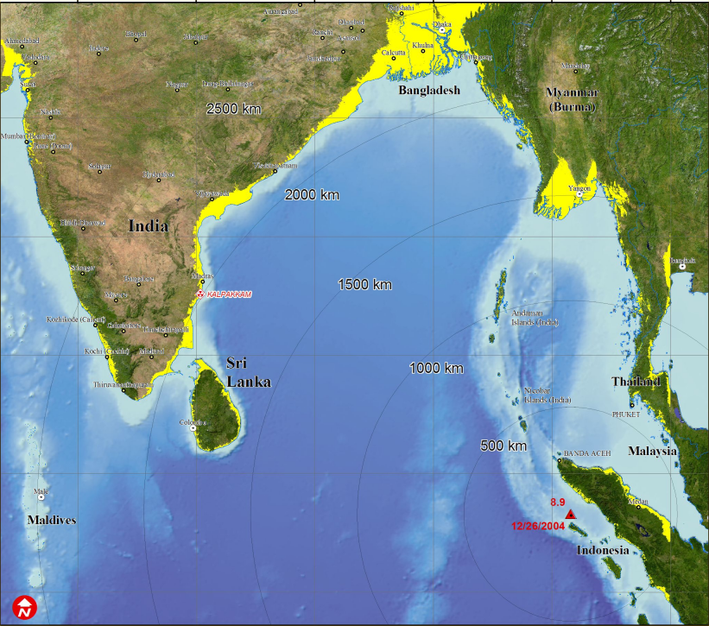
Vulnerable land = yellow (<20m)
Main impacts = red outlined
Much of this imagery has been geo-indexed through intensive effort by the UNEP-WCMC, and Figure 2 indicates the relative intensity of coverage of point observations and area coverage. Most of the links collated by UNEP-WCMC are to free imagery, however, there are also a large number of commercial sources of satellite imagery, some of which are subsidising costs, or are negotiating special arrangements.
Figure 2. UNEP-WCMC IMAPS Tsunami web mapping
(see: http://tsunami.unep-wcmc.org/imaps/tsunami)
Several institutes have presented simulations of the tsunami wave (see e.g. UNEP’s website at http://www.unep.org/tsunami/images/image001.png). The force of the tsunami waves appears to be very uneven across the region, and only field assessment can reveal the actual impact. For further information about the hydro-dynamics and geology, please follow the satellite and data links available at http://www.wetlands.org/Tsunami/Tsunamidata.htm.

In summary, satellite and mapping materials available have been collated most effectively by the UN sponsored Disasters Charter partnership (see: http://www.disasterscharter.org)

Assessments available of the coastal wetlands
Assessments of the impacts have been led by the need to immediately target humanitarian relief, but while these actions were often in the news, several international agencies rapidly assessed coastal livelihood issues, for example:
- the UNDP/World Bank/FAO reported on a joint assessment for Thailand conducted in the period 4-8 January;
- FAO issued its first regional report on fisheries, aquaculture and coastal livelihoods on 7 January, followed by reports from each of its country agencies.

Many assessments conducted by the development assistance community within the region or at country level contain information relevant to “green reconstruction” of the coast, and should be referred to.
- Key links to these assessments and portals can be reached by clicking on the assessments and maps link at: www.wetlands.org/tsunami.

In this report, the key findings within assessments performed by members of the Ramsar Tsunami Reference Group are reported. In addition relevant assessments reported by other agencies are sunmmarised.

Ramsar Sites – status.

We know where Ramsar Sites potentially exposed to the tsunami are located, these are named in Figure 3 below. Those thought to be tsunami-affected are in the southern part of the region shown, however, little is known about their current status.
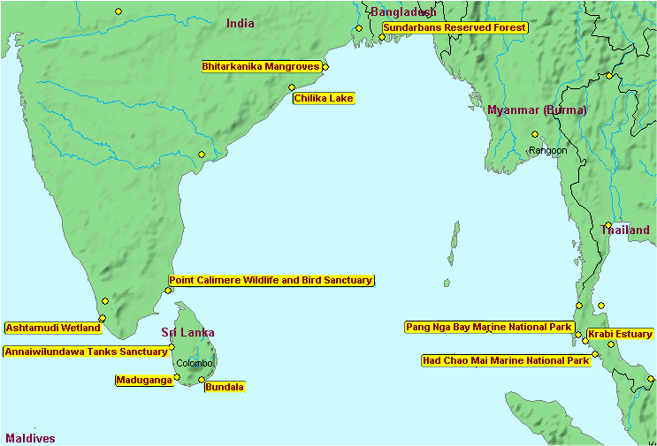

Important Bird Areas (IBAs) are distributed throughout the affected area (see Figure 3), and those in the Andaman and Nicobar Islands may be most severely affected. Little specific post-tsunami assessment information is available for IBAs, however, BirdLife has published a review of IBAs and their key species to use to target rapid assessment, and this extensive data set has been collected together and posted in the Library for the Sites and Species impacted discussion forum reached via www.wetlands.org/tsunami

Figure 3. Important Bird Areas potentially affected (source BirdLife International)
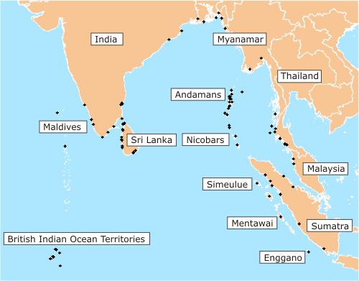

Assessments by Country

India (including Nicobar and Andaman Islands)

Areas impacted

UNDMT Situation Report: The hardest hit areas are the Nicobar and Andaman Islands and the southern provinces of mainland India (Kerala, Tamil Nadu, Pondicherry, Andhra Pradesh), with Tamil Nadu by far the worst affected. About 2,260km of coastline was affected, but very little information is available about the status of wetlands.

FAO reported extensive damage to fish and shrimp hatcheries in all provinces.

Shallow waters (corals and seagrass)

CORDIO/IUCN: a rapid assessment has been initiated by the Suganthi Devadason Marine Research Institute - Reef Research Team (SDMRI-RRT) a week after the tsunami to assess the status of corals and associated shallow water habitats. One site each near the islands of Kariyachalli and Vaan in the Tuticorin group and one patch reef site near the mainland were assessed. The results of surveys conducted at the island sites revealed that there was very little damage to coral reefs and associated habitats caused by the recent tsunami. The rapid assessment is continuing for other island areas (Vembar, Kilakarai and Mandapam groups) in Gulf of Mannar

Inter-tidal (mangroves, fish & shrimp ponds)

WWF is collecting data on the role of mangroves in lessening the impact in certain areas, and is calling for an immediate moratorium on any further mangrove destruction and the immediate restoration of lost mangroves, and is also calling for the strengthening of laws on regulating development in coastal zones.
M S Swaminathan Research Foundation reports that in the Pichavaram mangrove wetland, occupying an area of about 1400 ha, located about 280 km south of Chennai, in the Cuddalore District, there was no damage to 6 hamlets that are physically protected by the mangroves but hamlets located on or near to the beach have been totally devastated.
Upper beach and tree zone (turtles, shelter belt trees)

WWF reports that turtles have been sighted on several beaches on the Andaman and Nicobar Islands.

Inland (fisheries, rice)
No specific information collected

Thailand

Areas impacted

Six provinces were affected: Phuket; Ranong, Phang-Nga, Krabi, Trang, Satun. Of these Phang-Nga was most seriously affected [source: WI] With the exception of Phuket - which has long been heavily developed for tourism - the remaining 5 provinces represent the most heavily mangrove forested provinces in Thailand and contain almost 175,000 hectares, or 70% of the nation’s mangrove resources. The Natural Resources and Environment Ministry has said it will declare the provinces of Krabi and Phang-Nga as “environmentally protected areas” in order to give it more power to regulate rebuilding, redevelopment and planning. The Forest Department wants to re-zone the coastal parks to become more tsunami-resistant.

Regarding Ramsar sites and others, BirdLife reported that Krabi River Mouth was to some extent sheltered, or the impact of the tsunami dissipated by the many coastal inlets.

Thematic summary

Shallow waters (corals and seagrass)

FAO states that at least 5.9 sq km of coral reef and 3.9 sq km of mangroves have been damaged
Damage to aquaculture floating cages has been estimated as probably less than US$ 32.7 million, with a total of about 1.1 million square metres(or 41,439 cages) for marine fish culture, 179 rai (approximately 30 ha) of shrimp farms and 434 rai (approximately 70 ha) of shellfish area being damaged. The damage is expected to drive Thai shrimp exports down by 75 000 – 80 000 MT this year.
UNDP/World Bank/FAO reports that only 5% of coral along the Andaman coast has been damaged, much less than originally thought. However, substantial to severe damage is located at South Patong Beach, Koh Pai (Phi Phi), Rana Bay and Similan Island.

WI’s overall assessment is that:
- Coral, at depths in excess of 5m is unlikely to have been significantly damaged.
- Reports estimate about 5 – 10 percent coral destruction from areas surveyed in Phuket, Krabi and Phang-Nga Provinces.
- Coral damage in the Similan Island group, and Surin Island group is thought to be significant. Photos show coral “boulders”, in excess of 1m in diameter, thrown up onto the beaches and some reefs are reported as suffering 70% damage, or more.
- Localised coral damage, dependant on location, is estimated at up to 90 percent.
There are further serious risks of indirect impacts to coral and there are concerns that more losses will be suffered through the following mechanisms:
- The serious disturbance of the seabed, combined with the volume of organic and non-organic materials, debris, sand and silt that has settled on coral as the tsunami receded has, will cause longer term damage.

Trang Province, and in particular the Chao Mai Ramsar site, which lies within the tsunami zone, have the most extensive seagrass beds in Thailand. As a result, Chao Mai is also a location of rich marine biodiversity, including significantly Dugongs (Dugong dugon) and critically endangered Hawksbill turtles.
Preliminary reports on seagrass at Hat Chao Mai suggest that it is not extensively damaged or lost, but in many places has been damaged, torn out and seagrass has been found washed up on the beach.

Inter-tidal (mangroves, fish & shrimp ponds)

WI states that Phang-Nga Province, which recorded the most serious human casualties, is also the province with the highest amount of mangrove in Thailand. This suggests that if there is indeed damage to mangrove forest it is most likely to be in Phang-Nga.

Upper beach and tree zone (turtles, shelter belt trees)

UNDP/World Bank/FAO reports that at Haad Thaymuang, urgent recovery of the beach nesting site is required for Leatherback and Olive Ridley turtles

Inland (fisheries, rice)
No specific assessment reported

Indonesia

Areas impacted

WI: The areas that were closest to the epicentre of the earthquake and therefore most seriously affected by the tsunami include the coast from Meulaboh to Banda Aceh, Aceh Besar and Aceh Jaya, including Simueleu Island. There are many reports that one of the reasons that damage on the island was minimized was because of the formation of the coastal wetland ecosystem, that was complete and in relatively good condition, including coral reefs, seagrass and (on the east coast of the island), mangroves. To date information is only available on the mangrove ecosystem. In contrast to the situation on Simeulue Island, reports from residents in Pulo Aceh group of islands state that coconut trees that stretched along the beach were uprooted by the tsunami. This situation leads to strong speculation that the entire coral reef ecosystem, the turtle breeding beach, and seagrass beds (habitat for dugong) were completely destroyed.

Shallow waters (corals and seagrass)
WI: It is estimated that the most serious damage occurred to coral around the Pulo Aceh Islands, and that damage to Weh and Simuelue Islands was moderate. It is thought that the coral around the Banyak Islands is still in good condition
Based on the location of the islands and the damaged caused by the tsunami on land, it is estimated that the damage to seagrass beds in the Pulo Aceh islands is 100%, while damage is 50% in the Simeulue and Weh Islands.

Inter-tidal (mangroves, fish & shrimp ponds)

WI: In 2000 the remaining area of mangrove forest in Aceh that could be considered in good condition was only 30,000 ha, including the mangrove that is found on Simeuleu Island. Damaged mangrove covered 25,000 ha, and mangrove in moderate condition was distributed over 286,000 ha.
The table below shows the length of the coastline and the estimated area of mangrove on the east and west coasts of Aceh.
Location | Length of coastline (km) | Total area of mangrove (ha)
North coast to east | 761 | 296,078
West coast to south | 706 | 49,760
Simeuleu islands | 1.000 | 1,000
The above data shows that while the length of the coastline is almost the same on both coasts, the area of mangrove on the east coast is six times more than on the west coast.
To date there is no accurate quantitative data on the level of mangrove destruction caused by the tsunami. Available information consists of reports from local residents and humanitarian volunteers who have seen the situation in the field and also from photographs of the coast taken by volunteers. Based on this information, it is possible to estimate mangrove damage as follows:
- Aceh Besar, 100%, 26,823 ha
- Banda Aceh, 100%, <500 ha
- Pidie, 75%, 17,000 ha
- Aceh Utara and Bireun, 30%, 26,000 ha
- Aceh Barat, 50%, 14,000 ha
The above data might over-estimate the damage caused by the tsunami as it could include damage that took place before the tsunami struck. This possible discrepancy is caused by the fact that it is not clear what criteria were used by the Department of Forestry in preparing the report on mangrove coverage.

Upper beach and tree zone (turtles, shelter belt trees)

WI: The tsunami damaged approximately 50% of the sandy beaches of Aceh. This damages includes changes to the sandy coastline and also refuse and substrate that were carried as the tsunami waters receded.

FAO: surveys of damages to coastal aquaculture ponds along the coast indicate serious damages, ranging from 40 – 60 percent of the ponds in the various districts (worst hit is Bireuen).

Inland (fisheries, rice)

WI: The damage to rice fields is difficult to estimate because they are spread from low to high land. From a satellite photo it was determined that all of the rice fields in Aceh Besar, covering 30,000 ha, were damaged by being submerged in tsunami waters.

The damage to aquaculture ponds on the west coast was most extreme in Banda Aceh, Aceh Besar and Pidie, where the level of destruction was 100%. Damage in Bireun and Aceh Utara was approximately 50%. The level of damage of coastal aquaculture ponds could be as high as 27,000 ha, more than half the total area of ponds in Banda Aceh

FAO: 30 981 ha of the rice production is reported to be damaged. In the districts of Aceh Utara, Bireun, Pidie, Aceh Besar, Aceh Java, Aceh Barat and Nagan Raya a total of 90, 350 ha have been destroyed (47, 955 ha fish ponds and 30 981 ha paddy fields.

Malaysia

Areas impacted

FAO: The northern states of west coast of Peninsular Malaysia have been badly affected, these include Kedah, Penang Perlis and Perak. Penang and Kedah suffered the most damage.

Shallow waters (corals and seagrass)

FAO: Key issues of concern are the destruction of floating cage farms in Kedah which grow various marine fish species located at the river mouth, fishing ground for bivalves and floating cage farms.

Inter-tidal (mangroves, fish & shrimp ponds)

WI reports uprooting and complete loss of coastal mangrove belts in some areas of impacts.

National Hydraulics Research Institute Malaysia (NAHRIM) reports that at a project site at Kuala Sala, Kedah and thanks to the mangroves, damage to surrounding areas including Kampung Burma, was minimal. However, unprotected coastal areas, about 2 km southwards from the research station were severely eroded.

Upper beach and tree zone (turtles, shelter belt trees)
No specific information collected

Inland (fisheries, rice)
No specific information collected

Sri Lanka

Areas impacted

The tsunami affected the coastline most severely from the southwest coast to the northeast coast though with varying degrees of impact. A rapid preliminary assessment carried out by IWMI on coastal wetlands three weeks after the event focused mainly on the southwest coast, between Hambantota and Colombo with the primary focus being in Hambantota District. IWMIs assessment looked at physical impact on where, why and how certain areas were more impacted than others.

FAO in its country agency report states that the mangroves, coastal lagoons and coral reefs acted as protection/buffer zones, lessening tsunami impacts

Shallow waters (corals and seagrass)

IWMI: Assessment on coral reefs have already started with preliminary surveys by the Global Coral Reef Monitoring Network (GCRMN) contributing to the International Coral Reef Initiative (ICRI) of the International Society for Reef Studies (ISRS). Jerker Tamelander, coordinator of the Marine Program of IUCN, said that preliminary surveys have been carried out in Hikkaduwa, Weligama, Unawatuna and Trincomalee and indicated that the coral reefs of Trincomalee (north east) have been devastated compared to the reefs on the south coast though there was a fair amount of damage. Local observations at the Hikkaduwa Nature Reserve displayed limited damage to the existing reef structure other than for a few toppled boulder corals and a few lesions.

Inter-tidal (mangroves, fish & shrimp ponds)

IWMI: It would be expected that mangrove would have been minimally affected due to their root systems making them very resistant to water surges which seem to go along with reports from various sources around the country. Our personal observations at Kalametiya showed large mangrove trees of Sonneratia sp. uprooted /collapsed at a distance of about 200 m away from the beach area.

Upper beach and tree zone (turtles, shelter belt trees)

IWMI: Sand dunes - Observations made on the sand dunes on the Hambantota coast which are vegetated with Casurina trees and invasive shrub species seem to have protected the immediately adjacent areas inland.

Inland (fisheries, rice)
No specific information collected

What we don’t yet know
Most information collected by the Ramsar Tsunami Reference Group on the case for natural mitigation is non-quantitative, and is site-specific. We do not know the situation across huge areas of coastline, especially in Sumatra, Andaman and Nicobar Islands and north Thailand/Myanmar. In addition the situation in the western region of the Indian Ocean has not been examined by the Group. Quantitative data that would be a high priority to collect includes:
- Estimates of the energy and wave height that impacted key areas where it is suspected that e.g. coral reefs, mangroves, beaches played a part in mitigation
- Map-based assessment of the pre-tsunami situation for the full suite of wetland types and livelihood dependence, to enable follow-up full assessment.
Priorities both geographic and thematic for rapid or comprehensive assessment are also required to be set, to enable more efficient targeting of resources, and policy interventions.

There are many other things that we do not know, and possibly do not recognise the need for, and so regular liaison and brainstorming between partners is essential.

What we are finding out or will soon know
Each of the Ramsar Tsunami Reference Group is either entering into a series of rapid assessments or is planning to do so. These will cover the full range of wetlands and livelihoods issues.
BirdLife is planning to systematically assess the post-tsunami status. Their preliminary analysis shows that 27 globally threatened birds species regularly occur in the regions and habitats of Asia potentially affected by the tsunami. There are three Endemic Bird Areas and two Secondary Areas in this part of Asia, and up to 88 Important Bird Areas that might have been affected.

Despite the wealth of biodiversity in the region affected by the tsunami, this preliminary assessment indicates that few (if any) threatened species are likely to have been seriously affected by its direct effects, and no extinctions are predicted as a result of the tsunami. However, surveys are needed to confirm the situation, particularly in the Nicobar Islands.

Wetlands International is working with the Ministry of Forestry in Indonesia to perform joint rapid assessments, with a strong emphasis on livelihoods and the priorities for wetland restoration – where feasible. A national workshop will be convened on 8th February in Jakarta to set priorities and integrate efforts further. Other ministries are also involved in joint environmental assessments, and it is intended that WI staff will be embedded in these field assessment teams. In Thailand, Wetlands International will mount a field rapid assessment of specific sites, including Krabi, where a project is located, and will try to obtain more specific information about coral damage and mangrove mitigation. In Malaysia, Wetlands International staff will target efforts at Penang and Kedah state, to assess the fisheries/wetlands status and evidence for mangrove mitigation. In India, a relationship with the Bombay Natural History Society and others will provide more systematic investigation along the south west coast, but there are still large gaps in knowledge for the southeast provinces.

IUCN is continuing to concentrate its efforts in Thailand and Sri Lanka and is currently undertaking
assessments regarding biodiversity loss, impacts on fisheries and tourism, and land use planning, and will continue to do this over the coming months with key partners. Globally, the Marine, Forestry and Water and Wetlands Programmes are coordinating efforts to follow-up assessments across the region.

WWF Indonesia is working in Indonesia with the Aceh Forum, a coalition of local NGO's, which is helping with the management of refugee camps and aid distribution. And it is working closely with the Ministry of Environment (with WI) which is due to carry out assessments of the environmental impact. WWF in India is collecting data on the role of mangroves in lessening the impact in certain areas, and is calling for an immediate moratorium on any further mangrove destruction and the immediate restoration of lost mangroves. WWF India is also investigating the strengthening of laws on regulating development in coastal zones. WWF is part of the UNEP tsunami task force, and is engaged in dialogue and meetings. UNEP is helping co-ordinate various environmental assessments in the region.

IWMI will continue to support assessment and rehabilitation efforts in Sri Lanka. In collaboration with IUCN, IWMI has produced a concept note to map the Sri Lankan coastal wetlands on the basis of remotely sensed imagery and focused biomonitoring, including the creation of a national database. Digital GIS and SRS maps of wetland sites are to be produced by the GIS / RS Group at IWMI, in consultation with IUCN and CEA. The project objectives could be amended to enable attention to be directed at the tsunami impacted areas.

Many other partners including FAO, UNEP, country UNDP offices, are also aiming to increase assessments, and a great deal more environmental information will be available for the upcoming UNEP Governing Council meeting scheduled on February 15.

Who’s who in coastal wetland assessments and restoration
The international Ramsar Tsunami Reference Group of partners (IWMI, WWF International, IUCN, BirdLife International and Wetlands International) represent wetlands expertise, however, other international and national organisations have complementary and substantial capacity to assess coastal wetlands and livelihoods and also assist restoration:
Regionally:
- UNEP has established a Task Force (with IUCN and WWF membership), and intends to perform field assessments in Indonesia, Sri Lanka, Thailand, Maldives, Seychelles. General rapid assessments start in mid-February, and repprt to UNEP Council in early April.
- FAO has concentrated upon fisheries (including artisanal coastal, fish and shrimp ponds), forestry (mangroves and coastal forest)
- IFAD is assisting the governments of India, Sri Lanka and Indonesia through micro-finance to coastal communities including assessments targeting fishing.
In India:
- World Bank, ADB and UNDP are collaborating on a joint field assessment in February in the five provinces affected (Kerala, Tamil Nadu, Pondicherry, Andhra Pradesh, Andaman & Nicobar Islands)
- MS Swaminathan Research Foundation has posted mangrove assessments and is hosting workshops including on the Andaman & Nicobar Islands about the concept of a coastal ‘bio-shield’ through plantation programmes with people’s participation.
In Indonesia:
- UNDP/World Bank/Bappenas in the Consultative Group on Indonesia, published its assessment and a recovery framework on 19-20 January
- ITTO has agreed to assist Indonesia with mangrove restoration
- CIFOR (Center for International Forestry Research), is assisting through workshops
In Sri Lanka:
- IWMI ( in addition to its regional role) provides remote sensing, maps and transport for survey teams

Role and capacity of the Ramsar Tsunami Reference Group

Each organization outlined their role and focus in dealing with the tsunami (as at 17 January 2005) .
BirdLife International | - Focus on adding value in relation to threatened species, threatened waterbirds and IBAs that are affected.  - Consultation with strong national BirdLife partners to identify the impacts - gathering info and species and sites – focus on biodiversity value of sites.  - Identifying measures relevant for reconstruction and future mitigations.  - Provision of support to students from Aceh (Indonesia) who have lost their university course and support them in Java and local communities at IBAs in Sri Lanka.  - Have capacity for on the ground site assessments (except Aceh) and to advocate through NGO partners to involve local and national govt.
IUCN | - Working with governments, IUCN offices are producing summaries of key issues for decision makers in Thailand and Sri Lanka.  - Capacity building programme – for how to incorporate nature and environmental issues in rehabilitation  - Hope to establish consortium of organizations to support assessments and long term monitoring – see this as priority for involvement in the Reference Group. Would like link with WI, with UNEP and other organisation, building on relative strengths. IUCN have more strength in Sri Lanka, less in Indonesia.  - Focus needed to identify how we can coordinate this to get a collaborative action – on an urgent basis.  - IUCN is already a member of UNEP Task Force, and can provide the linkage to this group.
IWMI | - Already involved in Sri Lanka with a hydrological assessment at one lagoon.  - A four day visit for rapid assessment will be undertaken this week, after which a better idea of the impacts in southern Sri Lanka.  - Sites where good bio date pre tsunami – will be a focus. Not sure if surveys in some site will be possible due to current condition – debris and human bodies.  - Have collated imagery with different resolution for the whole country (Sri Lanka) and focus is to map it digitally and get the information out. They are mapping affected areas and have links through to others who have information. Need assistance to analyse information.  - Have offices in India and Thailand and could get them involved.  - Part of CGIAR, who aim to coordinate their members  - World Fish Centre and FAO have set up CONSRN to undertake impact on fishery in the affected countries.  - Focus is on ensuring efforts that benefit livelihoods.
WI | - Indonesia, Thailand, Malaysia and India – preliminary assessments undertaken/underway. Indonesia team working very closely with central and district, organizing a workshop with government to bring the parties together to id. info needs and link it to decision making and spatial planning.  - WI role is to lead collaboration with others in the further development of these wetland assessments, in order that we can bring information together at the regional level and make it available to decision-makers  - Partnership with ITC Netherlands developed to manage remote sensing data on behalf of the Ramsar Reference Group. ITC has many students from the region who are willing and able to do assessments using baseline info pre and post tsunami. WI needs information from partners on wetland assessment information that is available and priority areas for case studies. The capacity for ground-truthing in each country also needs to be established  - Doug Taylor is the main contact to develop WI’s assessment work. He has collated the information on our website on available mapped assessments. This site will be used to present analyses of the Ramsar Tsunami Reference Group to external audiences. See www.wetlands.org/tsunami  - The moderated discussion forum is just starting up to enable information and ideas to come together, under specific topic headings. Others are invited to participate in it – information will feed into the Ramsar processes.  - WI has some links to donors and re-construction programmes and is keen to work with other partners to coordinate on this.
Ramsar Convention | - The Convention is the user of what we can pull together and provide it to the Contracting Parties.  - Information being generated needs to feed in as initial advice to the Ramsar STRP in early February, then in early March to the Ramsar Standing Committee Sub-Groups and then in June to the full Standing Committee.  - The Convention is organizing a special forum in conjunction with WWD in early February during the STRP meeting in Gland.
WWF | - WWF has offices in India, Thailand, Malaysia and Indonesia. A staff person is missing in Indonesia from Banda Aceh. Field activities affected by the Tsunami in Thailand, India and Indonesia.  - Relief effort - WWF Malaysia and Indonesia both involved with offices being used, have also helped mobilise human resources (doctors etc) and military planes with food and medicine.  - Initial environmental impacts. Working with Ministry of Environment in Indonesia and India Government in Andaman. WWF India (Delhi Office) has worked on a mapping project of the Andaman. WWF is also working with the UNEP Task Force.  - Have developed media releases dealing with issues of "green reconstruction" and mangrove protection and are keen to see a coordinated engagement with these issues.  - WWF have produced a web page on this issue that is linked to others - http://www.panda.org/about_wwf/where_we_work/asia_pacific/news/news.cfm?uNewsID=17950

References
See: www.wetlands.org/tsunami

