Executive summary
The aim of the present study is to identify and consider technical evidence about the negative impacts that lithium brines development has upon water resources and wetlands in the Puna and High Andes area in Argentina, Bolivia and Chile, an area commonly known as the “Lithium Triangle” (see Map 1).

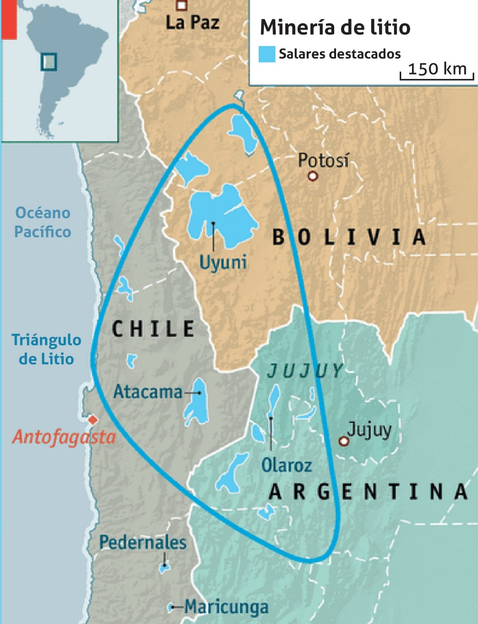
Map 1.- Lithium Triangle in South America. Modified from: Apex in The Economist (2017).

In general terms, the basins of this region are typically circumscribed by mountain ranges, and there are lakes or brines lying in the centre of these basins. The hydrogeologic model that we have adopted for our analysis —and which is also applicable to all the High Andean region basins— is
the one proposed by Rosen (1994), who refers to them as playa (not to be confused with water beaches, which are also called playa in Spanish), and defines them as intracontinental basins showing negative water balance and a capillary fringe which is shallow enough to enable the phenomenon of evaporation
from the water table.
According to this model, the main water balance governing these basins comes from the recharge of water caused by precipitations in the marginal mountain ranges and the discharge by evaporation of groundwater in the central parts. Due to the arid and dry climate, the surplus of water generated by ponds and wetlands is maintained in time by the inflow of groundwater and, to a lesser extent, by perennial streams (if there are any).
Wetland ecosystems develop in those sectors of the basin where the geomorphological conditions favor the accumulation of water or moisture from groundwater and, consequently, constitute the last link in a chain whose balance is already fragile, since any alteration of the water cycle, in these conditions of extreme aridity, can have negative repercussions on the water table and all the elements that depend on it.
In the context of an energy transition towards cleaner technologies, the main challenge facing human efforts is making the development of natural resources compatible with preservation of the environment and the rights of local communities. In that respect, production lead times, the methods used, the design of the main facilities in the mine sites and the related infrastructure take precedence in the discussion as those factors —elements— that, as well as enabling the extraction of the mineral, should ensure that the interaction with the environment is as harmonious as possible.
The evaluation of the impacts of lithium extraction in wetlands (see Impact Assessment Matrix -Annex-) was made considering the unique natural characteristics of the environment in which this activity is carried out, as well as the general characteristics of mining projects, evaluating its different stages, namely prospecting, exploration, development or production and reclamation of the mine; since it is each stage of the project which determines the space-time scale of the impacts. From all of them, the production stage is the one that has a greater impact on the environment —especially on wetlands— and is also the stage about which there are more documents available; therefore, we proceeded to analyze the negative impacts in each country that was taken as a case study —Argentina, Bolivia and Chile. The mine reclamation stage deserves to be addressed specifically, since restoration of the
environment after the extraction depends on it; nevertheless, there are still no ongoing reclamation stages for the projects of lithium extraction in Latin America and, because of that, there is no technical material available to make an evaluation. A preliminary projection has been made for the environmental liability of the Olaroz-Cauchari project in Argentina, caused by the inadequate final disposal of the Dangerous Waste from the abundant discard salts that do not contain lithium. Should the current inadequate practices persist, this liability would reach a minimum value of USD 450,000,000 (four hundred and fifty million US dollars), which would imply that the project would not be financially or environmentally viable.
Only in two of the three countries under analysis are there projects going through the development stage. In Chile, the one that has made the most progress, there are several projects at the development state, as well as a rich institutional control culture which has generated a multiplicity of documents, pieces of research and registers of this extractive activity. The Atacama Salt Flat (Salar de Atacama), considered a worldwide reference, is developed in a way that has been cautiously organised in accordance with the technological level adopted there. However, after thirty years of extraction, serious problems have been detected as a result of the intensity of the extraction of fluids, which has grown beyond the levels that the environment could resist, given that its negative impact on water resources and wetlands is evident and well-documented. The generalised drop of the water table, the desiccation of carob trees and even slight changes in some climate variables affecting the basin have been documented both by the Chilean environmental authority and by scientific works.
On the other hand, the Argentinean experience, which is more recent, shows only one project at an early stage of development —the Olaroz-Cauchari salt flat in the province of Jujuy— and some others at the stage of prospecting or exploration. The development of the Olaroz-Cauchari salt flat (case study) is not as intense as that in the Atacama salt flat yet, but the documented environmental impact is very high because of the weak provincial institutional culture there, which does not establish adequate controls for this kind of fragile environment, as well as business practices which are not in line with the due diligence required for environmental care, externalising the costs of the environmental liabilities generated by those very businesses.
The lack of an environmental monitoring network prevents the quantification of the impact; however, as can be drawn from the documents published by the mining company itself, the site was, from the very beginning, built with precarious infrastructure, without contemplating the delicate natural conditions of the basin and prioritising profit maximisation at the expense of a minimal investment in infrastructure. The likely result is the alteration of the water cycle of the basin due to the interruption of the water flow to the areas of natural discharge and a high risk of irreversible pollution of the freshwater sources due to the facilities which have been inadequately built and incorrectly placed.
In order to systematise the information and aid comparisons, we have elaborated an Impact Assessment Matrix -Annex- which summarises the main environmental impacts detected, their characteristics, the source of information and a category that indicates whether these are demonstrated or likely.

The main impacts that have been documented and identified are the following:

⯈ Salinisation of soils and wetlands.
⯈ Soil pollution caused by hazardous waste.
⯈ Alteration of the natural surface water flow.
⯈ Alteration in the salts precipitation cycle.
⯈ Alteration of water balance.
⯈ Environmental liability. Violation of Law 24.051. Executive order 831/93. Technology Requirements for disposal operations (section 33, annex iii).
⯈ Unacceptable disposal operations.
⯈ Risk of breaks in evaporation pools caused by torrential flows and/or earthquakes.
⯈ Salinisation of wetlands and soils with exotic salts.

⯈ Salinisation of subterranean freshwater reserves de reservas hídricas in the Archibarca alluvial fan in Jujuy.
⯈ Effects on the native flora.
⯈ Alteration of the lacustrine/wetland systems.
⯈ 90% increase in the salinity and acidity of soils..

Taking this information into account, productive projects need to reach financial viability while avoiding, without fail, the undesirably lazy business approach of maximising profits through the externalisation of liabilities and the infringement of applicable regulations. Both the role of the State as regulator and scientific and technical research are key to achieve this. On the other hand, companies have not shown any remarkable development in that respect so far; instead, they have not gone beyond applying the most basic technology available (evaporation pools) with only minimal care for the environment when building their facilities.

The foundation needed to materialise any undertaking is having previous knowledge of the natural system to be interacted with, the opportunities and limitations it implies, and the effective institutionalisation of the territory under the applicable laws or other laws that will, eventually, need to be made. This requires investment which is specifically allocated for the preparation of thematic maps of the territory, monitoring of the main environmental variables (precipitation, temperature and atmospheric variables in general; evaporation, groundwater levels, chemical composition of waters and many more) as well as integrated models that account for the interaction and dynamics in place among natural elements.
The placement of mine facilities at the edge of the basin to preserve alluvial fans, the use of horizontal drilling (whose efficiency has been proved in the oil industry), methods for lithium separation through fluids without evaporation, with reinjection and secondary recovery are some ideas that could work in order to organise the development and take the pressure off the basin resources.
Lastly, a new development paradigm is possible through a combination of environmentally committed businesses, a State that takes an active role, and an involved civil society.

Introduction

Lithium has traditionally been used in the production of glass, ceramics, lubricants, psychiatric medications, lubricating grease, air conditioners, polymers and metallurgy, among others. However, due to the exponential growth of the electronic industry of rechargeable battery powered portable devices, international demand for lithium has increased in the latest years, as lithium is a mineral with excellent properties for the production of rechargeable batteries for mobile phones and computers (Henríquez, 2018.)
In the year 2016, international demand for lithium for rechargeable batteries production reached 39%, and it reached 30% for glass and ceramics production, showing a significative growth in comparison with, for instance, the year 2011, when the figures were 29% in the former case and 35% in the latter. In 2015, the main consumers of lithium were South Korea, with 16,000 tonnes of lithium carbonate; the United States, with 13,000; Japan, with 12,000; China, with 11,000; Belgium, with 8,000 and Germany, with 3,000, which was mainly used in the computer, mobile phone and electric car industries (Argentine Agency of Mining Economy, 2017.)
It is in the last of these areas, the car industry, that the demand for lithium is showing the greatest increase, since it is the main component of electric and hybrid vehicles. Many car manufacturers are already competing for state-of-the-art technology in order to lead the electric car market, which, according to projections, will be predominant in the future (Zicari, 2015.) As well as consolidating the status of lithium as a strategic element, this has caused an exponential growth in the international demand for lithium, which reached 201 tonnes of lithium carbonate equivalent (LCE) in 2016 and is estimated to reach 372.288 tonnes of LCE in 2021, 59% of which would be used for battery manufacturing, whereas 38% of it would be used for electric cars (COCHILCO, 2017.)
In geological terms, and according to government sources in the mining sector, the term resources refers to mineral concentrations which are identified and estimated through explorations, samplings and analyses, and which are of financial interest and whose eventual extraction is in prospect; on the other hand, reserves are the part of a mineral resource which is measured and noted, being economically developable in a given productive, technological and environmental scenario considered within the scope of a mining plan. The commercial and strategic relevance of lithium has motivated numerous measurements related to the existing lithium resources and reserves in the world; however, these two do not necessarily coincide (Henríquez, 2018.)
On a global scale —and according to the Argentine Agency of Mining Economy and the United States Geological Survey (USGS, 2014)— salt flats represent the largest potential lithium reserves (58%), specifically, salt flats in the Southern Cone High Andes. Of that total, the resources found in the Lithium Triangle amount to 68%, of which Bolivia makes up 30%; Chile, 21%, and Argentina, 17%. Table 1 outlines the main projects of lithium development in the salt flats of the Puna and High Andes. It is worth mentioning that what is shown in this table is what companies formally declare before the authorities, which tends to entail divergent interpretations regarding what is declared and the actual progress of the project.

Dirección de Economía Minera de Argentina, 2017.

